Project Design Phase-II
Technology Stack (Architecture & Stack)
Date | 30 June 2026
Team ID
Project Name | A-Comprehensive-Measure-of-Well-Being
Maximum Marks | 4 Marks

Technical Architecture:
The Deliverable shall include the architectural diagram as below and the information as per the table1 & table 2 Example: Order processing during pandemics for offline mode
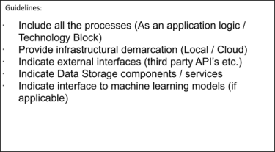
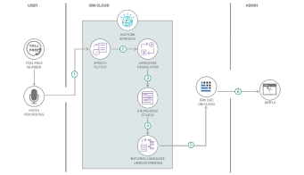
Reference: https://developer.ibm.com/patterns/ai-powered-backend-system-for-order-processing-during-pandemics

Table-1 : Components & Technologies:
S.No |  | Component | Description | Technology
1. |  | User Interface | Web and Mobile frontends enabling user interaction, form registration, login, and dashboard navigation. | HTML5, CSS3, JavaScript / React Native (Mobile), React.js (Web)

2. | Application Logic-1 | Backend API development handling user registration, authentication workflow management, and business rules. | Node.js (Express) / Python (FastAPI)
3. | Application Logic-2 | Speech-to-Text service utilized for voice-activated assistant commands within the customer dashboard. | IBM Watson STT service
4. | Application Logic-3 | AI chatbot assistant providing automated, contextual support queries for Customer Care workflows | IBM Watson Assistant
5. | Database | Local relational/non-relational development database for staging user profiles and system log data. | MySQL, NoSQL, etc.
6. | Cloud Database | Fully managed production cloud database ensuring secure, high-performance querying of transactional data. | IBM DB2, IBM Cloudant etc.
7. | File Storage | Cloud object storage container holding uploaded profile pictures, verification documents, and audit logs. | IBM Block Storage or Other Storage Service or Local Filesystem
8. | External API-1 | Weather services integrated to provide localized climate alerts directly onto the customer dashboard. | IBM Weather API, etc.
9. | External API-2 | Verification services utilized to safely cross-reference official user identity records during registration. | Identity Verification Gateway API
10. | Machine Learning Model | Image processing and verification models utilized to authenticate identity documents during user onboarding. | Object Recognition Model, etc.
11. | Infrastructure (Server / Cloud) | Isolated, containerized runtime environments for scalable web, mobile-backend, and database microservices.: | Kubernetes / Red Hat OpenShift on IBM Cloud

Table-2: Application Characteristics:
S.No | Characteristics | Description | Technology
1. | Open-Source Frameworks | Utilizing community-vetted, production-ready open-source code libraries to accelerate backend and frontend design loops. | Spring Boot / Express.js, Tailwind CSS
2. | Security Implementations | Multi-layer data protection incorporating credential hashing, session token transport, and strict role-based access. | SHA-256 / bcrypt, OAuth 2.0, TLS 1.3, IBM Cloud IAM controls
3. | Scalable Architecture | Decoupling application features into isolated services so individual modules (like Auth or Chat) can scale independently | Microservices Architecture, Docker Containerization, Kubernetes Pod Autoscaling
4. | Availability | Mitigating single points of failure by spreading workloads across physical nodes and maintaining redundant backup systems. | IBM Cloud Internet Services (CIS) Load Balancers, Multi-Zone Regions (MZR)

S.No | Characteristics | Description | Technology
5. | Performance | Keeping response times low and data access fast by optimizing resource caching and localized distribution techniques. | Redis Cache (Session management), Akamai / Cloudflare CDN (Static asset delivery)

References:
https://c4model.com/
https://developer.ibm.com/patterns/online-order-processing-system-during-pandemic/
https://www.ibm.com/cloud/architecture
https://aws.amazon.com/architecture
https://medium.com/the-internal-startup/how-to-draw-useful-technical-architecture-diagrams-2d20c9fda90d

